Alignment GUI demo

# Open ‘NewGUI.fig’

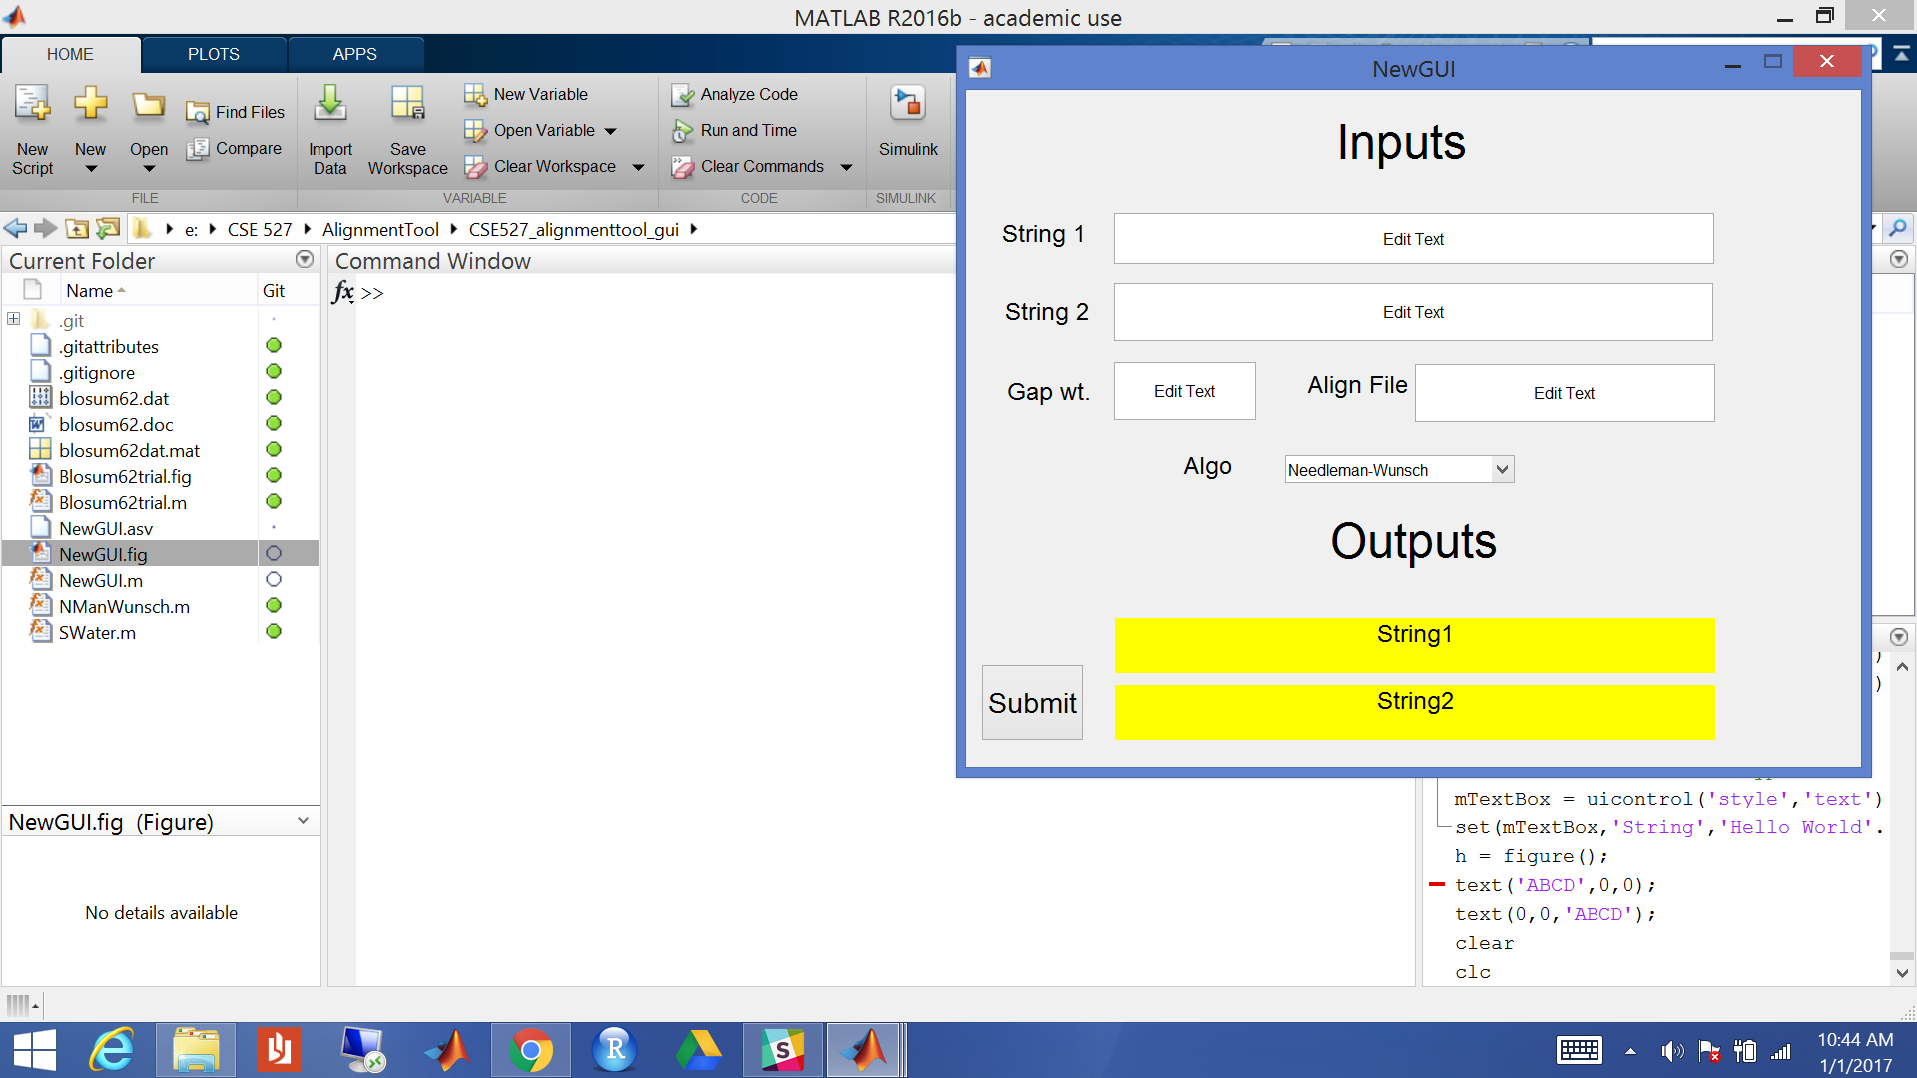

# Fill out input fields

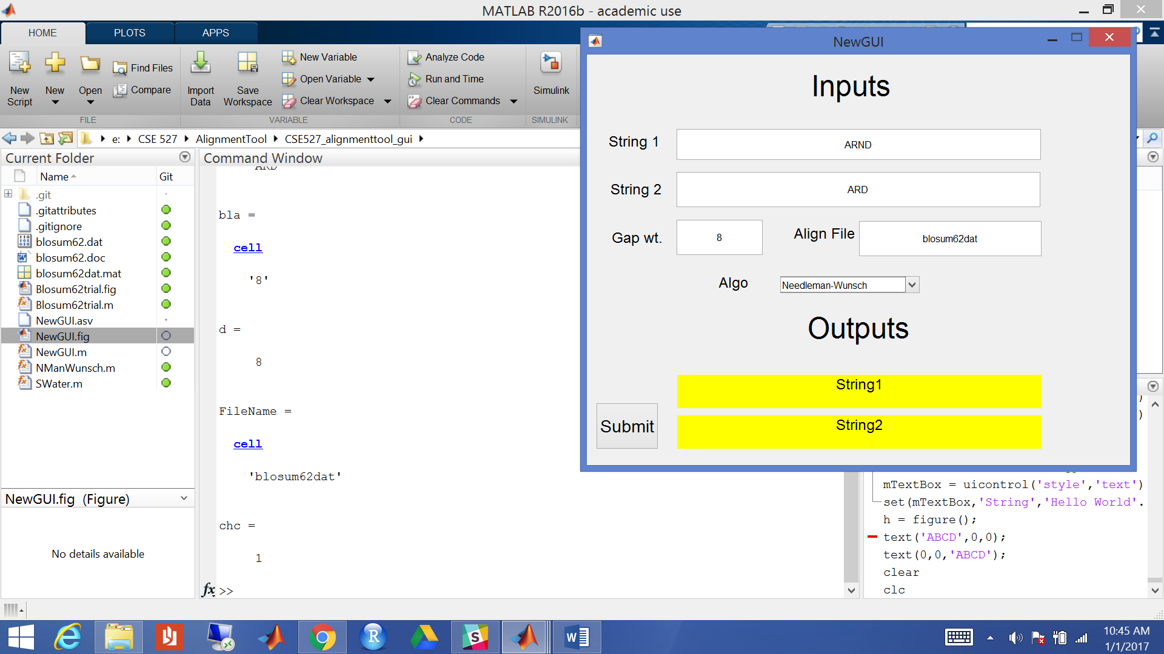

# Press the ‘Submit’ button

